“City Memory: Words of Nature”
the 6th Macao International Contemporary Illustrations Competition

Preface

Throughout history, human civilization evolves through altering nature itself and creating an artificial nature, bringing about new dialogues between humans and nature. Industrial civilization of three hundred years is mainly characterized by man’s conquest of nature, and the formation of modern civilization takes place in cities. The 21st century has witnessed a giant leap of the world’s industrialization. The breakthrough in life science and space strategy motivates humans with greater ambition to exploit nature, both the earth and space. As time goes by, ecological civilization rooted in Chinese wisdom is taking shape. People begin to rethink the relationship between man and nature, reflect on environmental issues, promote the harmony between man and nature, and strive to build a community of a shared future for the earth through a global treaty of multilateralism: including humans, wildlife and all other life forms share the earth.

Forest is the most primitive home for humans, covering nearly one-third of the earth’s surface. As an important natural resource, it is home to 80% of animal and plant species as well as insects and bacterium of all kinds. It is a crucible full of life, revealing life cycle with seasons: life thrives in spring and summer and then withers when fall and winter approach, symbolizing the joy of harvest and victory, an endless cycle of life and death. Being an important part of ancient human memory, forest is the cradle of civilization, and the inspiration of art. People in ancient times lived their lives in the forests, full of unknown, danger and mystery. Over thousands of years, humans gradually settled down in cities, labeling urban life, the product of large-scale of industrialization, as modern civilization. Meanwhile, Forests and wilderness are devalued and viewed as signs of being primitive and uncivilized. The development of social science and technology is changing people’s mindset. They seek to “live poetically” by revisiting nature and living their lives there in seclusion to heal the soul. Inspiration from philosophy and art has deeply influenced humans’ aesthetic perception of nature. Thanks to philosophers’ and artists’ efforts, people begin to appreciate nature in terms of aesthetics. Forest ecology is more powerful than any other human art form in that it relates to vast space, time-honored history, and ever-evolving diversity of life forms in terms of space and time. Only when people grow their understanding about nature scientifically, and have more time to immerse themselves into nature, experiencing the land of nature and injecting vitality into their secular life, can it be possible to “make art become civilization itself from the beauty parlor of civilization” (according to John Dewey).

Themed on “City Memory: Words of Nature”, this competition underlines the era’s discourse of city memory and the in-depth implications of the era endowed by the image of urban citizens, with their bodies and souls, returning to forests. The competition is open to designers, artists, and creative individuals from all over the world to collect their own “forest stories”, their fantasies about “mysterious forests” and their sci-fi editions of “urban forests” to explore the “Words of Nature” in the form of illustration, a form of visual creativity. Through visual art and innovative mindsets, we aim to reinvigorate ourselves to tap into the infinite possibilities of cities, forests, and nature. It motivates us to better cherish the accomplishments of material and spiritual civilization in the course of human development so that we can “live poetically” (according to Heidegger) in modern cities, and proactively construct ecological civilization, with humanistic values as the core, in a future-oriented manner.
Academic Advisor of the Competition: Doctor. Meng Shu

Regulations

- Theme: City Memory: Words of Nature

- Submission deadline: 30th September, 2022

- Types of works: Graphic illustrations (without restriction on media)

- Regions applicable: The exhibition collects from all over the world
- Open collection (no cap to the number of works)
- 50 specially-invited works (not applicable to award selection)

- Exhibition time: November 21st to November 25th 2022

- Venue: Chun Chou Tong Pavilion of Lou Lim Ioc Park, Macao

- Entry fees: Free of charge

- Schedule
No. | Date | Schedule
1 | September 30th 2022 | Collection deadline
2 | October 1st – October 8th 2022 | Preliminary selection
3 | October 9th – October 15th 2022 | Final selection
4 | October 20th 2022 | Releasing Shortlisted & Winners

- Awards
No. | Group | Awards | Quota
1 | Specially Invited Group | Certificate for Specially Invited Artist | 50
2 | Public Group | City Memory Grand Award | 1
3 |  | City Memory Gold Award | 1
4 |  | City Memory Silver Award | 1
5 |  | City Memory Bronze Award | 1
6 |  | City Memory Jury Award | 5
 |  | City Memory Excellence | 20
7 |  | Excellent Mentor Award | unlimited
Note: | - Recipients for the Grand Award, Gold, Silver and Bronze Award will be granted the travel allowances to Macao and invited to attend the award ceremony (4 recipients selected first, the Jury Award for candidate on the waiting list).  - For all the Grand Award, Gold Award, Silver Award, Bronze Award and Jury Award, etc., certificate and a collection of works will be issued as an encouragement.  - As an encouragement, electronic certificates shall be issued for Excellence Award.

- Work submission
(1). By Online registration system
Link: https://www.gtn9.com/collect/wy_home.aspx
* Entrants from the mainland, Taiwan, Hong Kong SAR and Macao SAR are available.
* Fill in personal information, relevant information of the work according to the prompts, and upload the work;

OR
(2). By e-mail
Application form download link (Dropbox):
https://www.dropbox.com/sh/8tsovc72us8fm12/AACkSgAHER7_cV-QiTQQLmL9a?dl=0
* Send the completed application form together with e-file of the work or work download link to ccipa_mo@ymail.com;
* The subject of Email need to be named in the form of "name & country & title of work & image serial number".

- Submission requirements
(1). The submission format of the works is:
- The shortest side of the file is not less than 21cm, the longest side is not more than 180cm;
- JPG format: Resolution - 300dpi, CMYK colors;
- No more than 8 pages for series of works;
(2). Please follow the naming convention of “name-country-region-work name-file serial number”.

- Notice
- After the confirmation of the entrant’s online registration for the 6th Macao International Contemporary Illustration Competition (hereinafter referred to as “the Competition”), the entrant must consent to give the authorization of his/her submitted work to Chinese Cultural Industries Promotion Association for the use of promotion, exhibition, various media publicity and print related to the Competition without any charge.
- All entries must be for non-commercial use (not for any commercial advertising or purpose).
- In order to ensure the fairness of the selection and evaluation, in the concept description notes or entries entrants are not allowed to include their names, stage names, nicknames or any symbols or words that can be used to identify the identity of the entrants.
- The Chinese Cultural Industries Promotion Association shall decide matters related to text editing, picture placement, page allocation, cutting and typesetting and have the final decision.
- All entries must not involve pornography, violence, defamation or other contents that violate public order and corrupt social custom.
- The entrant must confirm and guarantee that the owner of the entry or the one who has been authorized with the entry renders authorization of all rights, including but not limited to the copyright, design rights and all other rights of the entry, as well as relevant intellectual property of the entry.
- The terms and conditions of this agreement shall be governed by the laws of the Macao Special Administrative Region (SAR). The courts of the Macao SAR shall have exclusive jurisdiction over any appeal or dispute.
- The terms and conditions of this agreement are concluded in both English and Chinese. In case of discrepancies between the English and Chinese version, the Chinese version shall apply and prevail.

- Introduction to the jury

Bill Carman (USA)

Bill Carman has worked as a designer, illustrator, and art director. He continues to free-lance and exhibit his work nationally and internationally. Currently a professor teaching illustration and drawing, Bill has greased enough palms to be included in annuals like the Society of Illustrators NY, receiving both gold and silver medals, Spectrum Fantastic Art, with gold and silver awards, Communication Arts, 3x3, and American Illustration. 3d Total Publishing’s Sketching from the Imagination series (Dark Arts and Fantasy), Imagine FX, Magazine, International Artist’s Magazine, and DPI Magazine are just a few of the anthologies and publications which include Bill’s work. He maintains a client list including: Random House Inc. (children’s book), LucasArts Entertainment, Macmillan, Night Shade Publishing, Easton Press, Group One, Quality Inn Hotels, Avid Publications, Atari, SSI, TSR Inc., SETI Institute, Boise Weekly, Susan G. Komen Foundation, Arthritis Foundation, Dana-Farber Cancer Institute, Utne Reader, Idaho Fish and Game, NPR, Idaho Shakespeare Festival, Boise Contemporary Theater, Opera Idaho, and Plan Sponsor Magazine. Bill never stopspainting and drawing for exhibitions and occasionally still produces an illustrationthat lands a little off center. His book, “Imagery From the Bird’s Home: The Art of Bill Carman” is currently available from Flesk Publications.

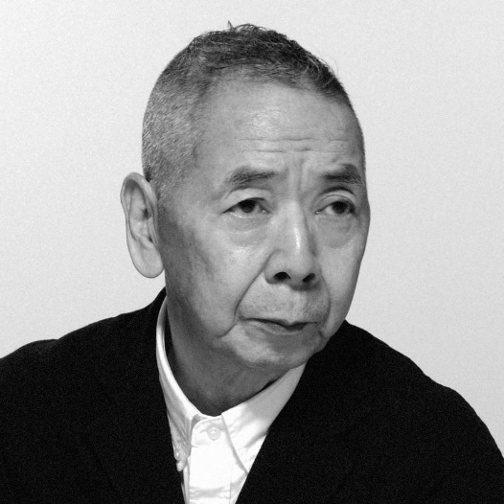

Shunyo Yamauchi (Japan)

Member of
Japan Graphic DesignAssociation Inc.(JAGDA/ http://www.jagda.or.jp)
Chubu Creators Club(https://www.ccc1973.com)
Council of Chubu Design Organizations(CCDO/ https://ccdo.info): Counselor

Awarded
The 1st 1977 Nippon Advertising Art Council Exhibition Encouragement Award (NAAC).
The 1st 1983 Japan Graphic Designers Association(JAGDA) Annual Exhibition New Artists Award.
1983 Japan Design Committee Design Forum Bronze Medal Prize.
The 10th Asia Graphic Design Triennale 2018(KECD) Silver prizes. others.

Dr. Kan Tai Keung SBS.BBS.AGI (Hong Kong, China)

Dr. Kan Tai Keung, an internationally renowned designer and artist, started his design career in 1967. His works won him numerous prestigious awards around the globe, which include “Hong Kong Ten Outstanding Young Persons” in 1979, “Urban Council Grand Award” in 1984. Kan is the first Chinese enlisted in 1995 “Who’s Who in Graphic Design” international reference book of Switzerland. He was awarded the Honour of Bronze Bauhinia Star and the Honour of Silver Bauhinia Star in 1999 and 2010 respectively. In 2016, Kan was awarded the “HKDA Lifetime Honorary Award” by Hong Kong Designers Association. Kan is keen on promotion of art and exhibitions. At present, he is the Honorary Dean of Cheung Kong School of Art and Design, Shantou University, fellow member of Hong Kong Designers Association, member of the Alliance Graphique Internationale, artistic advisor of the Leisure & Cultural Services Department, and honorary advisor of Hong Kong Museum of Art.

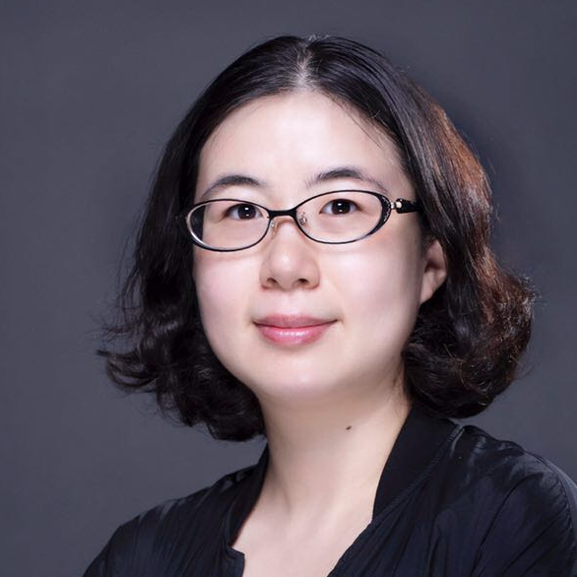

Dr. Meng Shu (Macao, China)

10 Fantasia－A Creative Industries Incubator (Macao) Art Director
Kiang Wu Nursing College of Macau Associate Professor
Chinese Cultural Industries Promotion Association Standing Director
Macao Sculpture Association Consultant

Meng Shu has successively presided over and participated in multiple national and Macao art research projects, and published her own book Meng Shu: With Dust With Light. To date, Meng has curated many art exhibitions and events in Macao, successively held her own contemporary art exhibitions for many times, and participated in over 50 contemporary art exhibitions at home and abroad. Her works have been collected by many national museums and renowned enterprises, including China Academy of Art in 2008, National Art Museum of China in 2019 and China Cultural Center in Tokyo (Japan).

Main curated exhibitions
2019 Art Macao: International Art Exhibition (Macao Government Tourism Office, the Cultural Affairs Bureau of the Macao SAR, SJM Holdings Limited)
2018 Contemporary Art Exhibition－New Approaches New Public: Memory and Release of the Pain
2014-2018 The first to fifth City Memory: Macao International Contemporary Illustrations Competition

Main solo exhibitions
2022 The Universe in Us: Contemporary Glass Art Exhibition by Meng Shu (Suzhou China) at Suzhou Jinji Lake Art Museum
2020 With Dust With Light: Contemporary Glass Art Exhibition by Meng Shu (sponsored by Macao Foundation)
2019 Celestial Sphere: Contemporary Glass Art Exhibition by Meng Shu (Macao Museum of Art, Grand Lisboa Macau)
2018 Stardust: Contemporary Glass Art Exhibition by Meng Shu (Ningbo)

Zhu Qiuzhen (China)

Shenzhen Illustration Association Executive President Secretary-General
Shenzhen Experience Design Association Vice-president
ALILI Art Curator

Independent curator, curator of China Illustration Biennial, founder of Global Illustration Industry Conference, judge of World Illustration Awards, judge of Annual Awards of Art+Craft in Advertising and Design

- Organizational units
Organizer: Chinese Cultural Industries Promotion Association
Implementer: C P Art Projects Development Company Limited
Support Units: Chubu Creators Club
Sponsor: Cultural Development Fund of the Macao Special Administrative Region Government
Submission platform cooperation: GTN9

- Contact Information
Email: ccipa_mo@ymail.com
IG: ccipa2020
FB: Chinese Cultural Industries Promotion Association
Web: https://ccipa.org.mo/
Phone：(+853) 2845 5113

