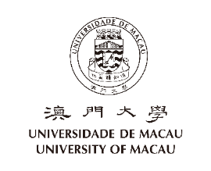
健康申報表 (須於假期後回校第一天上班填寫)
Health Declaration Form (Fill out on your 1st working day after resuming duty in office)

部門 Department: 職員編號Staff no: 姓名 Name:
申報日期 Declaration date: (dd)/ (mm)/ (yy) 簽名 Signature:
<<收集個人資料聲明Personal Data Collection Statement>>
本表格內所收集的個人資料為作健康申報之用，並有可能轉交本澳相關機構。The personal data collected on this form is for the purpose of health declaration and may be transferred to other organizations in Macao.
本人已閱讀並同意上述條款。 I have read and consented to the above terms.
- 你有否在過去14天內離澳 (包括週末、公眾假期及休假)? Did you leave Macao in the past 14 days (extend to weekend, public holiday and leave)?
否No 有 Yes，地點Place 回澳日期 Date for Return to Macao

- 你有否曾與新型冠狀病毒感染者接觸? Have you had contact with people infected with new coronavirus pneumonia?
否No 有 Yes

- 你有否下列症狀? (可多選) Do you have the following symptoms? (Multiple choice)
沒有出現症狀 No symptoms 發燒 (38° C 或以上) Fever (38° C or above)
急性咳嗽 Acute coughing
腹瀉 Diarrhea
肌肉酸痛 Muscle ache

- 你在校內或校外居住? Are you living on-campus or off-campus?
居住於校內 On-campus，座數及單位 Building and Flat:____________ 居住於校外 Off-campus

Last updated on 11/02/2020

