CONSUMABLE STOCK System

User Guide for Departmental Users

University of Macau

ICTO - IMS

Table of Contents

1. Introduction 2

2. Transaction Status Flow 2

3. User Roles 2

4. Getting Start 3

5. Stock Requisition 3

5.1 Shopping Cart 3

5.2 Approval for Stock Requisition Form 6

5.3 Status of Requisition 7

6. Reports 8

6.1 Requisition Records 8

6.2 Stock Sheets 9

# Introduction

The consumable stock system allows departmental users to apply stock requisition through shopping cart with approval process. This user guide contains all essential information to enable users to use the system step-by-step.

# Transaction Status Flow

User Stock Requisition

Stock

Out or Direct Delivery

Cancel

Complete

Approve

Submit

Back to Draft

# User Roles

User roles are configured through the Access Control Management (ACM) system.

|  |  |
| --- | --- |
| Roles | Enterprise Group  (For details, you could refer to the enterprise group admin from your unit.) |
| CMST_DEPT_REQUESTER | Department User who raise stock requests |
| CMST_DEPT_APPROVER | Department Head/User who approve stock requests |

# Getting Start

Go to <https://isw.um.edu.mo/>cmst.

Enter your user account name and password to login the system. The home dashboard displays all transactions status and numbers of forms with your user privileges.

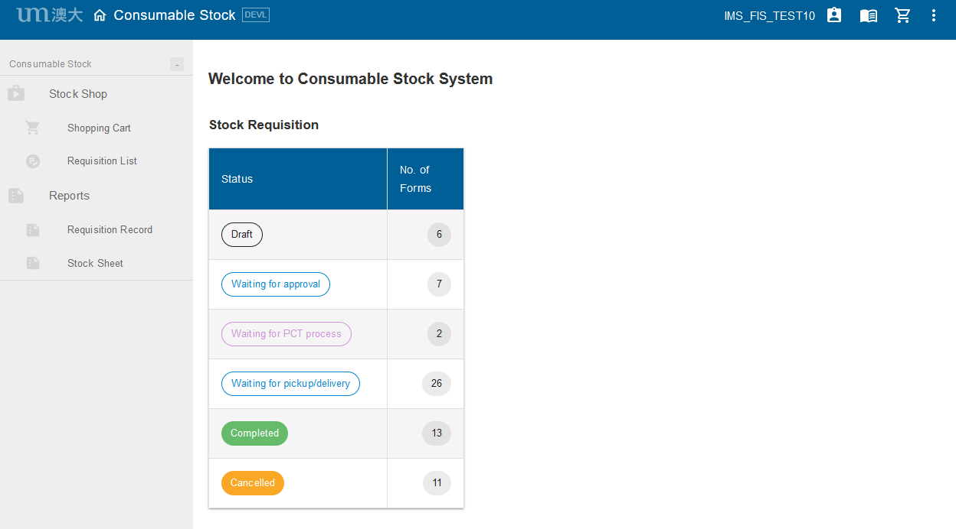

# Stock Requisition

## Shopping Cart

1. **Select items:**
2. Authorized department user (with role CMST_DEPT_REQUESTOR) (referred hereafter as user) can raise stock request from **Shopping Cart** on the left menu bar;
3. User may search the items by category or directly input the key words in the search bar;
4. Some items have “remark”, please read it before adding the item(s) to cart;
5. Each item has its “inventory”, user may check the current item inventory. If the inventory of individual item is “0”, user can still submit the requisition form;
6. Select items and input quantity, add to cart and finally **Checkout.**

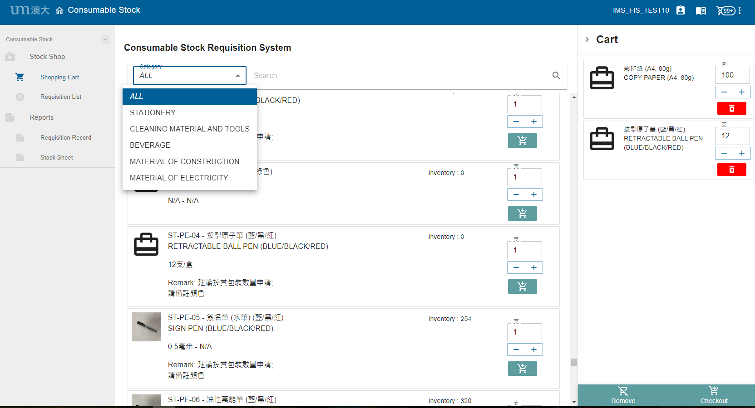

4

5

3

2

1

Remark: 建議按其包裝數量申請; 請備註顏色

1. **Save or submit the requisition form**
2. Choose request department if needed (one user may involve multiple departments request);
3. If there is (are) items that need(s) direct delivery, fill in contact information (including receiver, phone number, recipient address and remark for delivery);
4. Put remark for item specifications (such as color of pens, files, etc.), if any;
5. **Save** or directly **Submit** the form for approval.

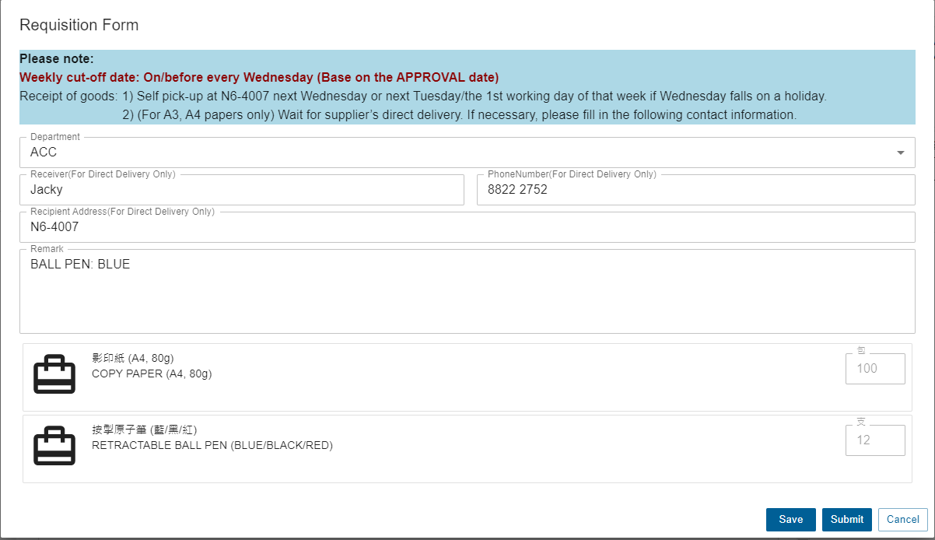

1. **Edit the saved requisition form**
2. User may add or remove item(s), adjust requested quantity and update information for direct delivery in the draft stage;
3. Additional items can be added by clicking the “+” button in the top right corner;
4. Be reminded to click **Save** before every leaving.

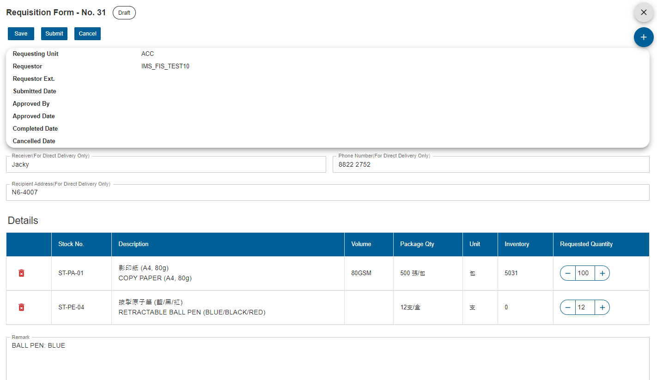

## Approval for Stock Requisition Form

Approver (role CMST_DEPT_APPROVER) can click “waiting for approval” in the home dashboard to view all the forms that will be approved by him/her.

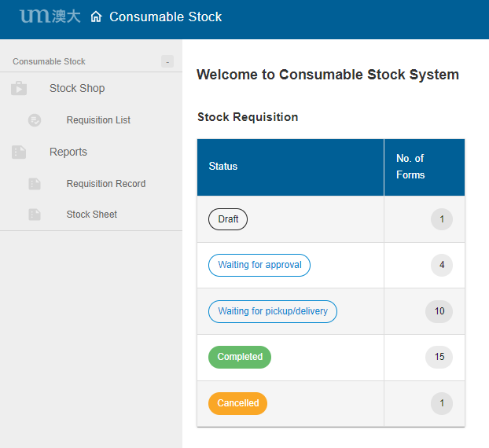

Approver can open the form by clicking .

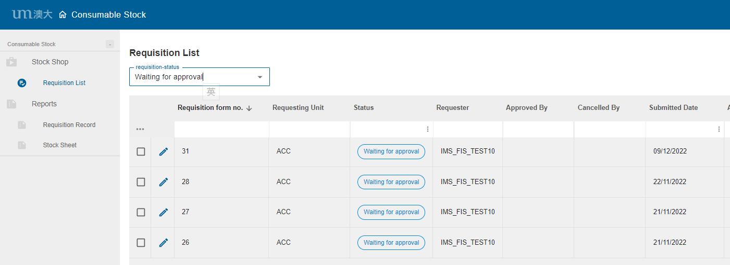

After the form is opened, approver may review the item details. If they are fine for approval, click the **Approve** button; if revision is required, click the **Back for Resubmit** button.

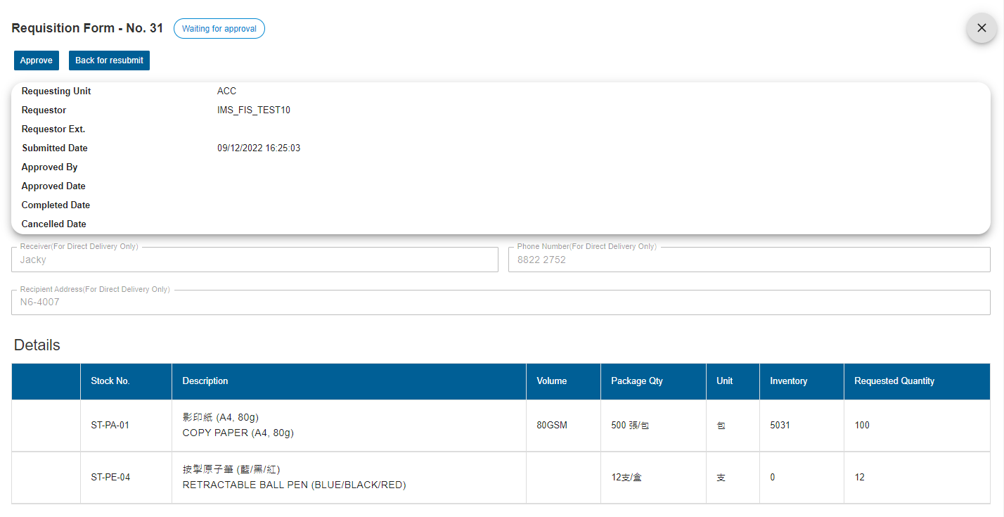

## Status of Requisition

User can click **Requisition List** to display all the forms with their respective status (Draft, Waiting for approval, Waiting for PCT process, Waiting for pickup/delivery or Completed) and other information.

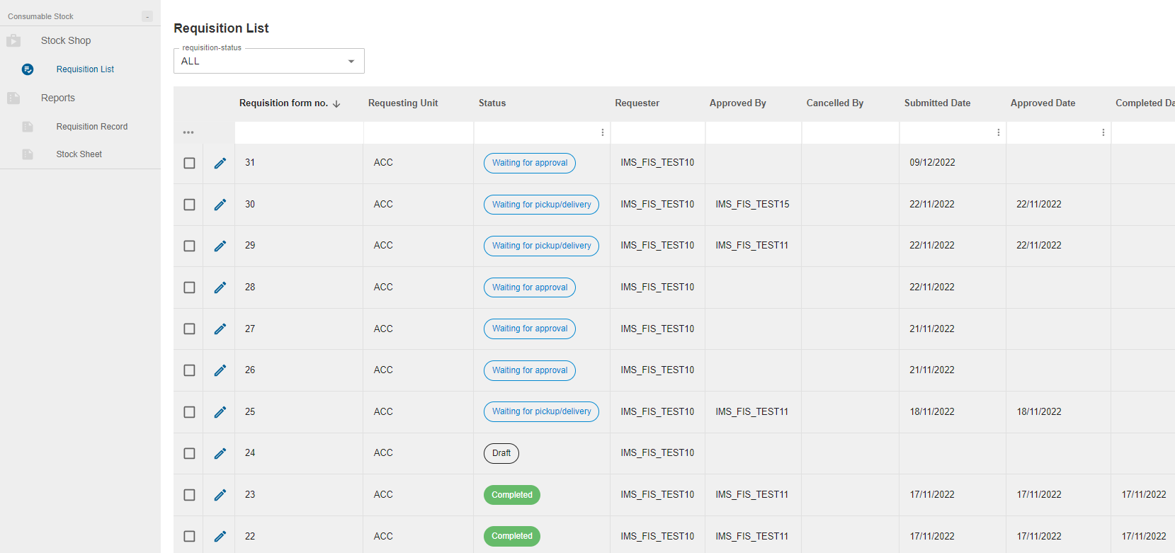

To follow up the requisition, by clicking , user may also check the status (Pending, Ready for Partial Pickup, Ready For Pickup, Waiting For Direct Delivery, Completed) of each requested item and the remarks from PCT in the form.

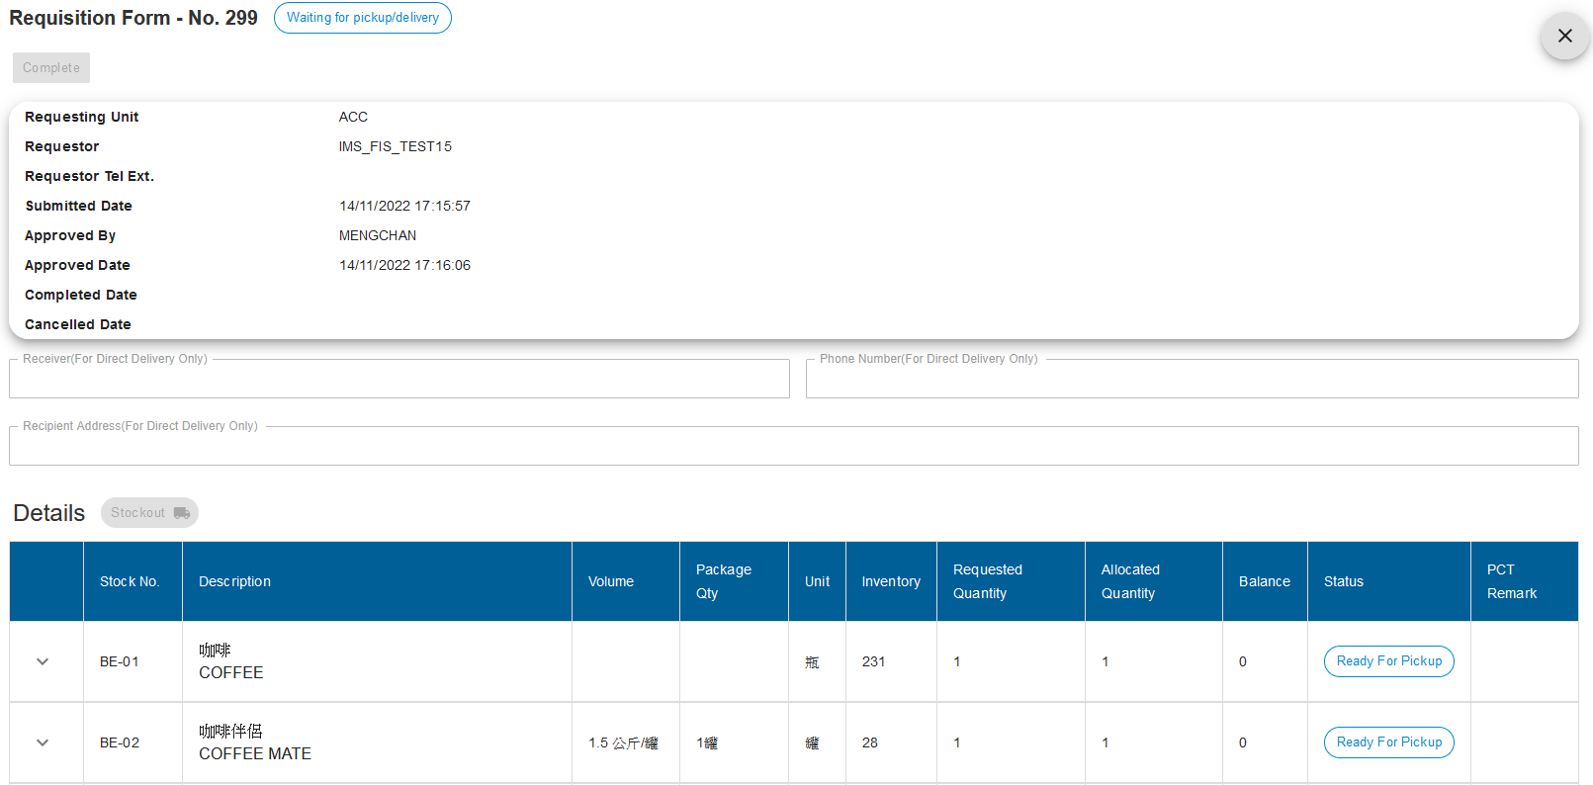

# Reports

## Requisition Records

If user needs to review the requisition records (including quantity, cost, etc.) of his/her own department, he/ she can go to **Requisition Record** and download the previous requisition records.

* Select Period From/To and Dept. Code

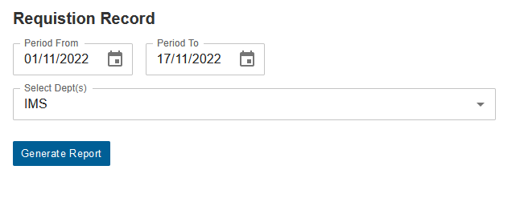

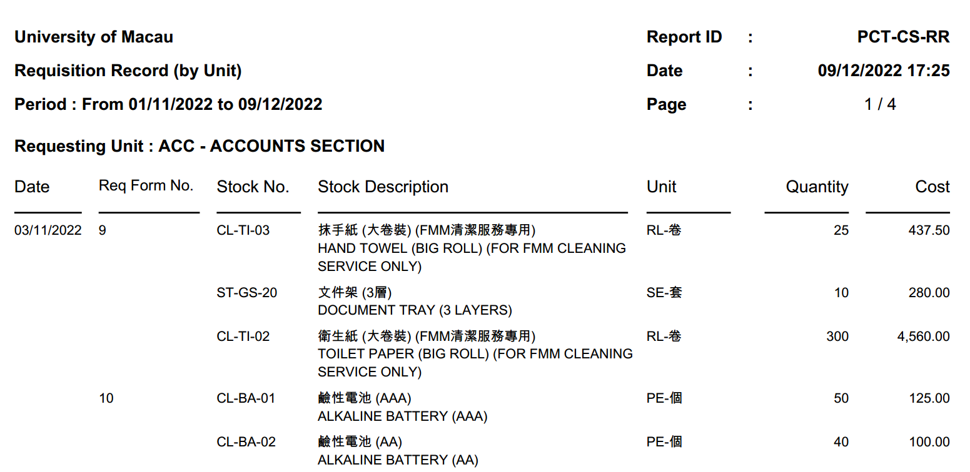

## Stock Sheets

If user needs to check the full stock list in the warehouse, he/she can go to the **Stock Sheet**, generate the list (in PDF/excel format) and view all stock items available for application and their current balance.

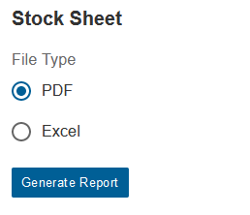 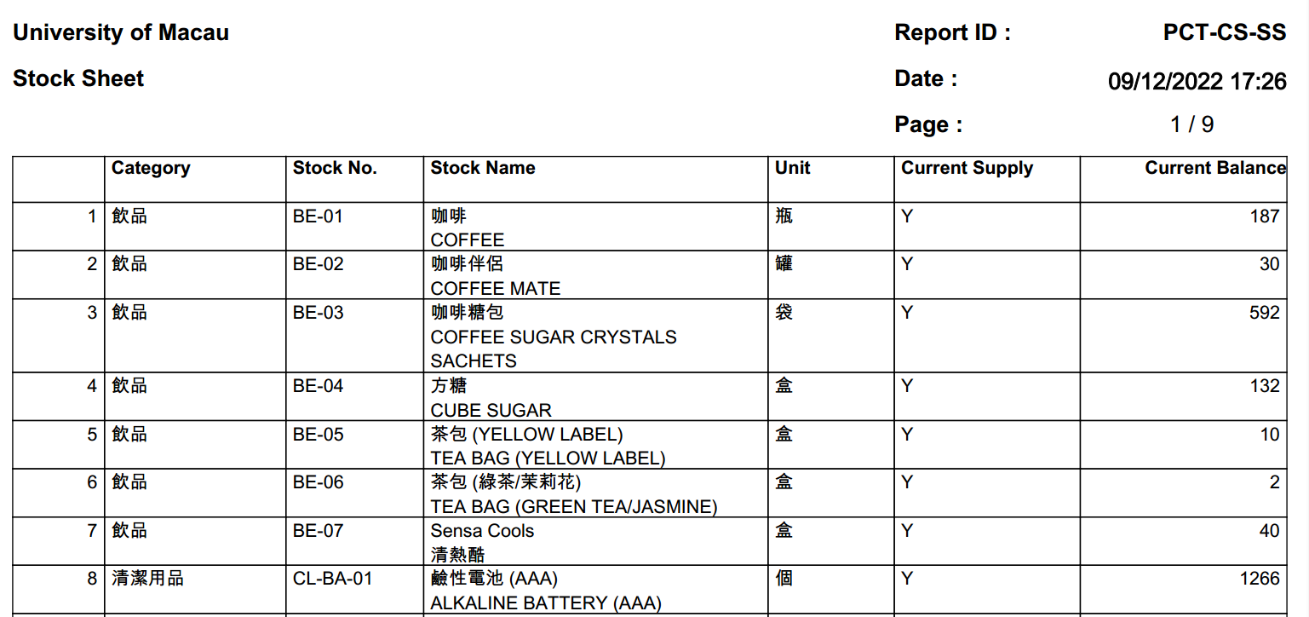

<< END OF DOCUMENT >>